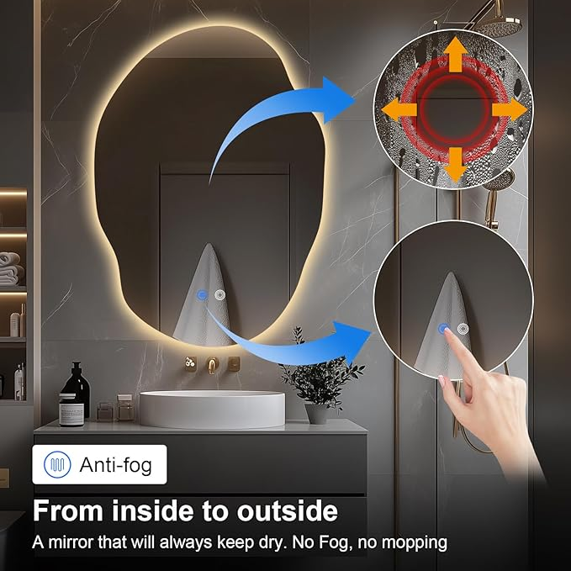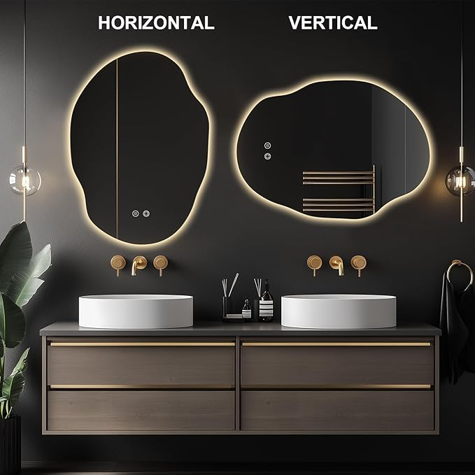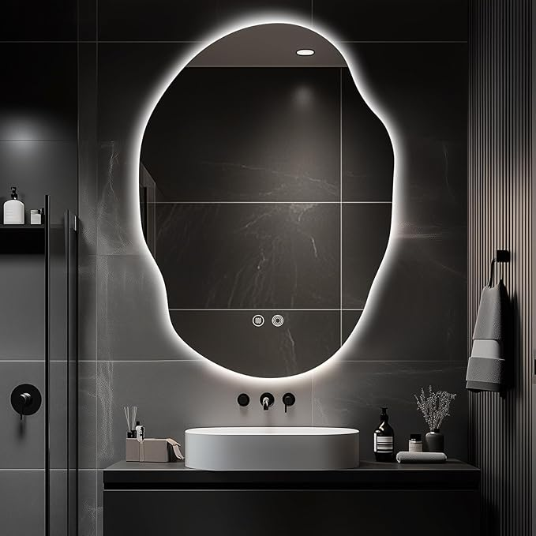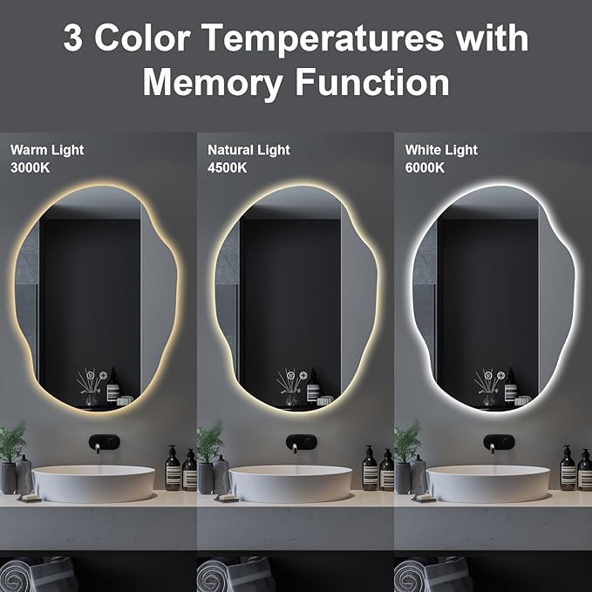

LED Bathroom Mirror with Lights,Asymmetrical Led Bathroom Vanity Mirror for Wall with Front and Backlit, Anti Fog, 3 Colors and Dimmable Light,[Horizontal/Vertical] 35" H x 25" W

**PRODUCT DESCRIPTION:**

|  |  |
| --- | --- |
| Brand | 39F USA |
| Room Type | Bathroom |
| Shape | Asymmetrical |
| Product Dimensions | 35"L x 25"W |
| Frame Material | Aluminum |

About this item

* Eco-friendly 5MM Asymmetrical Bathroom Mirror with Light: This LED bathroom mirror is made with copper-free, environmentally friendly materials and a silvered reflection layer for a clear and sharp image.
* Dimmable LED Light with 3 Color Temperatures: Choose from 3 color temperatures to suit your bathroom mood, with adjustable brightness via a touch sensor button for easy control.
* Anti-Fog Technology: The built-in anti-fog pad keeps the mirror clear after showers. The defogger and light functions are separately controlled for greater convenience and energy savings.
* Long-lasting & Easy Installation: With a lifespan of over 50,000 hours, this high-quality LED bathroom mirror is UL-certified and easy to install, supporting both wall switch control and plug/hardwiring options.
* Safety & Durability: The corrosion-resistant aluminum frame and IP54 waterproof rating make this asymmetrical LED bathroom mirror perfect for use in humid environments, especially over sinks.